Kubernetes

## Overview

**G**oogle **K**ubernetes **E**ngine (GKE) is a managed container orchestration service by Google.

GKE can be used to deploy a cluster of VMs that are managed by Google.

## Tutorial

In this tutorial, we will create a Kubernetes cluster using GKE, and also update the kubeconfig file.

### Install the gcloud CLI

Note: if you're using a GCP VM then you will already have the CLI installed and you will just need to authenticate.

sudo apt-get install apt-transport-https **ca**-certificates gnupg -**y**

**echo** "deb [signed-by=/usr/share/keyrings/cloud.google.gpg] https://packages.cloud.google.com/apt cloud-sdk main" | sudo tee -**a** /etc/apt/sources.**list**.d/google-cloud-sdk.**list**

curl https://packages.cloud.google.**com**/apt/doc/apt-key.gpg | sudo apt-key add -

sudo apt-get **update** && sudo apt-get install google-cloud-sdk -**y**

Once installed, you need to authenticate yourself with the GCP API by running the command:

gcloud auth login

### Creating the Cluster

gcloud container clusters create demo-cluster --num-nodes=2 --machine-type=n1-standard-1 --zone=europe-west2-c

This creates a GCP managed Kubernetes cluster, called demo-cluster, with two nodes.

We can check the cluster is running with the command:

gcloud container clusters describe demo-cluster --zone=europe-west2-c

### Update the config file

gcloud container clusters get-credentials demo-cluster --zone=europe-west2-c

This will create, or update, the ~/.kube/config file, which will allow us to interact with the Kubernetes API later on.

### Clean Up

To remove the cluster, simply run the command:

gcloud **container** clusters **delete** demo-**cluster** -

Gcloud <apiservice> cluster create <name><args> to create cluster

Node = single machine API - every node has an agent, kublet

We make requests to the API through http requests or a client like kubectl t ask it to run some workload for us. The API then takes care of determining where that should run and sends requests to kublet agent to tell it what to do

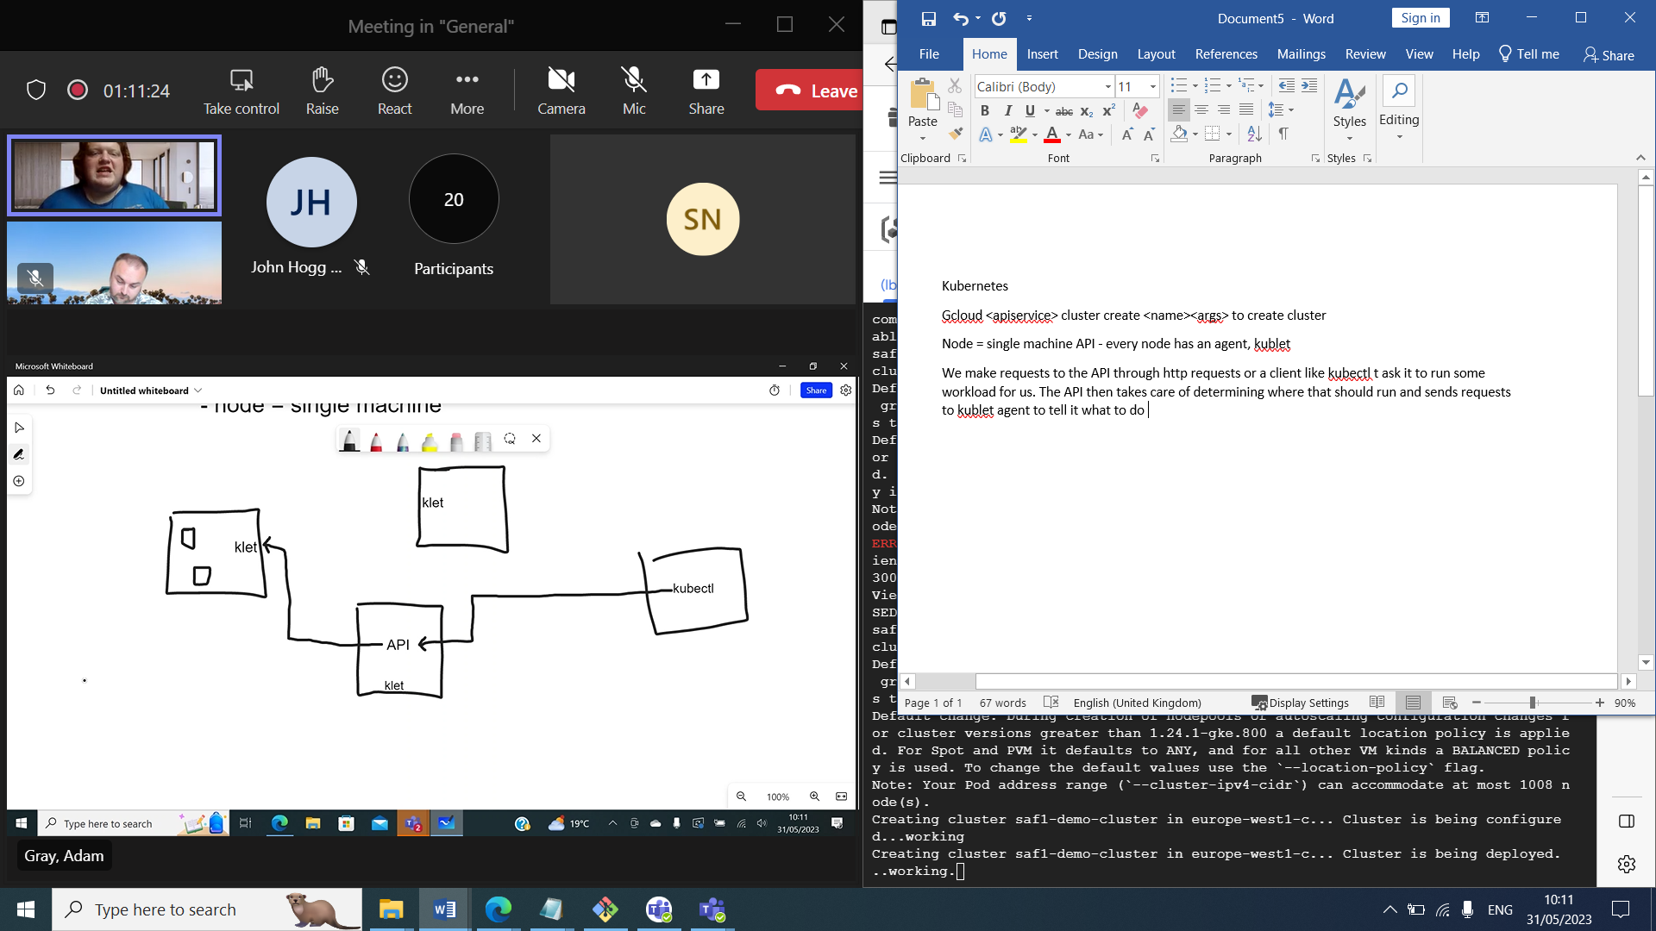

Benefit of kubernetes:

* Resilient if one goes down it will recreate
* 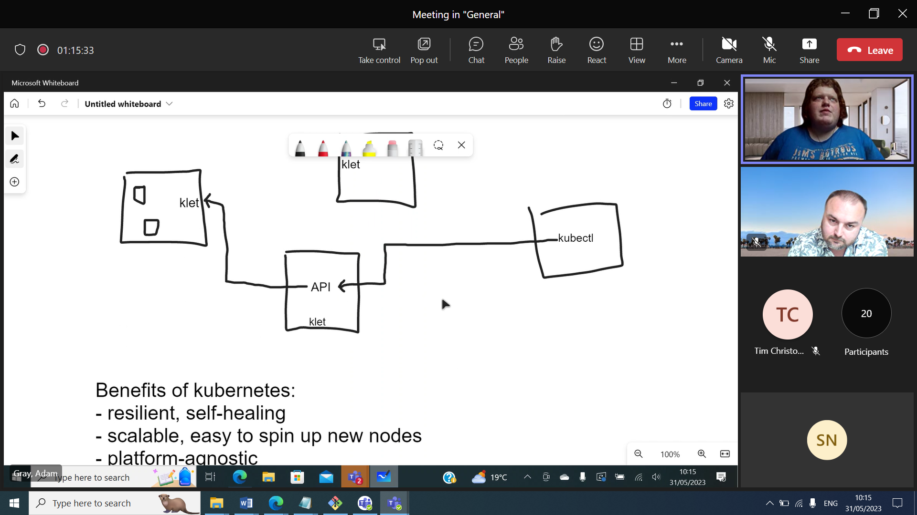

API allows for better access control -can run workloads without access to underlying nodes

Kubectl talks to the nodes in the cluster

Kubernetes

**Kubernetes** (k8s) is an open-source container orchestration system for automating deployments of containerised applications.

Kubernetes has many solutions for managing and scaling very large quantities of containers by grouping them into manageable units.

Because Kubernetes is open-source, it can be deployed as an on-premises, hybrid or public cloud solution.

Cloud services – such as Amazon Web Services, Microsoft Azure and Google Cloud Platform – offer managed Kubernetes services, which completely configure and deploy a Kubernetes cluster for you.

## Structure

A Kubernetes system is known as a cluster.

The following is a basic overview of how a cluster is structured and covers some of the most common **objects** you'll encounter when configuring a Kubernetes deployment.

**Note:** The following explanation is a simplification of how a Kubernetes cluster works under the hood. Understanding the full complexity of a Kubernetes system is out of scope for this course, but you can find more information in the [Kubernetes documentation](https://kubernetes.io/docs/concepts/).

### Pods

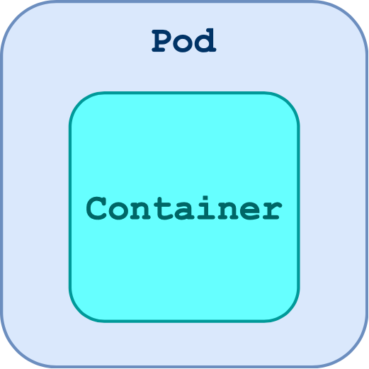

**Pods** are the smallest unit or object in Kubernetes. A single Pod consists of one or more containers.

A pod should do one function, and it should do it well.

The most common model is to have one container per Pod. This is generally the desired configuration for a Pod, as one Pod will then perform a single process.

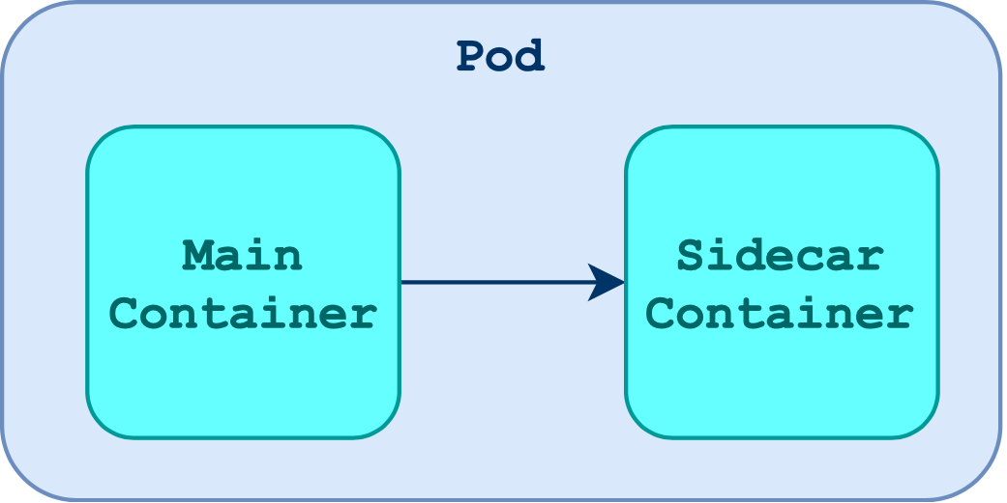

A less common model is the sidecar model, where two or more containers are tightly coupled inside a single pod.

Typically these extra containers are used for auxiliary processes such as log collection, rather than extending the functionality of the Pod's main process.

### Services

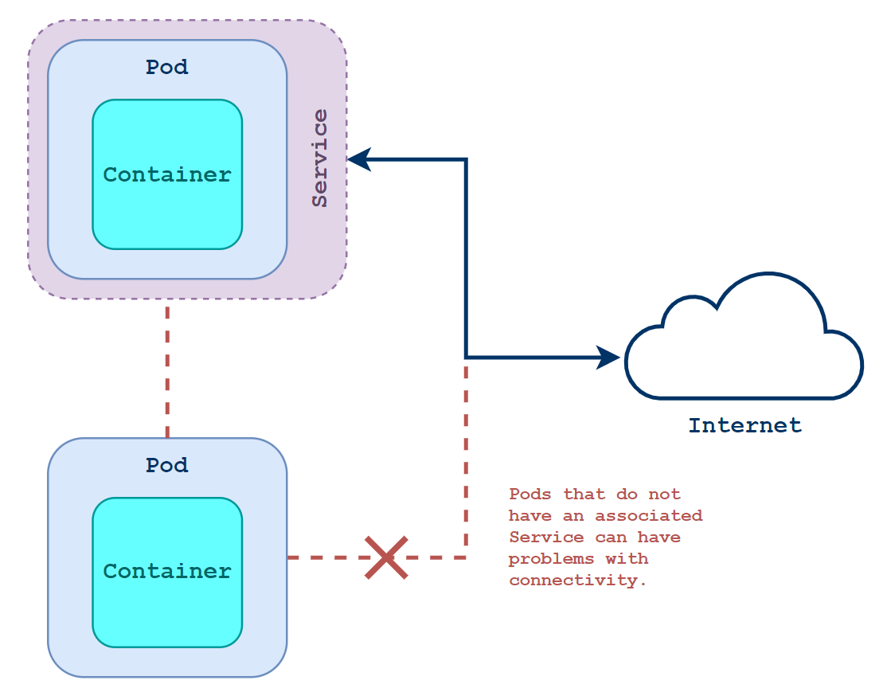

By default, when a Pod is created it is connected to the pod network and given a private IP address.  
This can cause issues when trying to get that Pod to communicate with other things, since Pods are ephemeral (they are often deleted and made again) each time they are created, they are given a new private IP address.

A better way to communicate with a Pod is to attach it to a **Service**.

Services are used to expose Pods to a other networks.  
This could be within the cluster, such as using a ClusterIP service, or to the internet, using a NodePort or LoadBalancer service.

Services also allow the ephemeral Pods to always be accessed from the same address.

### Controllers

Kubernetes is designed to manage and deploy containers (as Pods) on a massive scale.

As a result, one rarely creates and manages the deployment of an application using individual Pods.

**Controllers** are used to manage Kubernetes objects at scale by defining a desired state for the system.

A Controller will constantly check the current state of the system and automatically work to pull it into the desired state.

This process of constant checking is known as a control loop, and allows our Kubernetes clusters to self-manage with minimal human oversight.

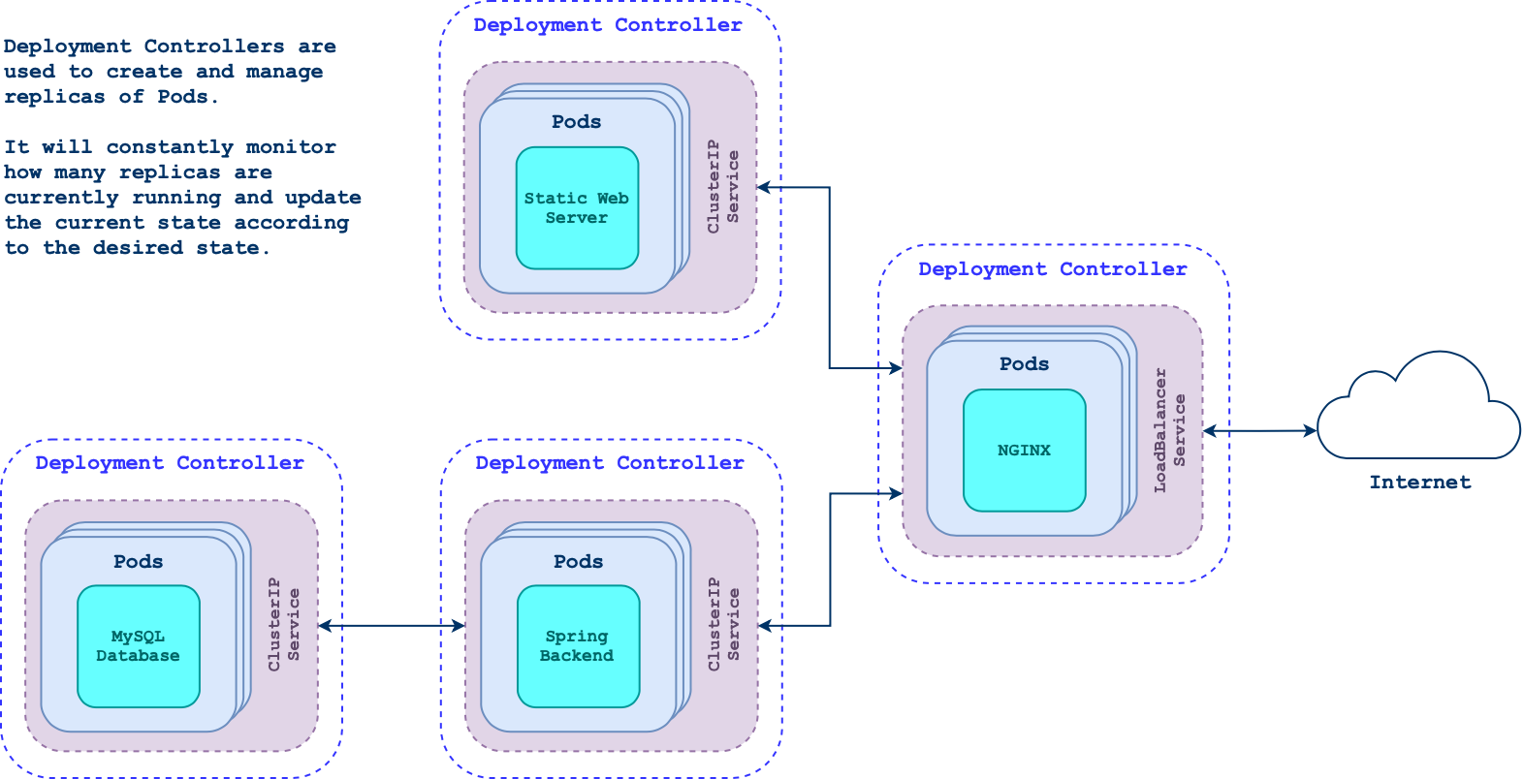

A common type of Controller is known as a Deployment, which allows us to specify the configuration of a multi-service containerised web application using one file. It also allows us to define its deployment strategy.

### Nodes

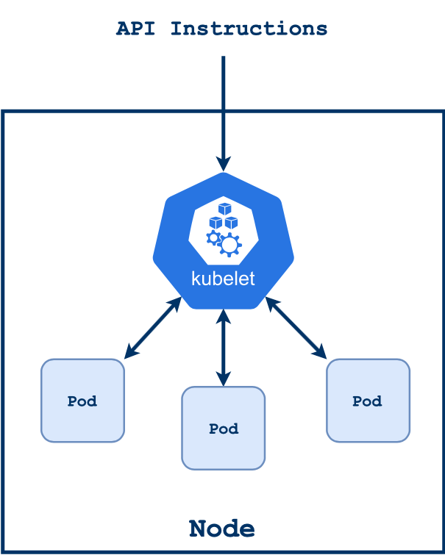

Pods in a Kubernetes cluster are hosted on **Nodes**.

A Node may be a physical or virtual machine and there may be any number of Nodes in a cluster.

Cloud-managed Kubernetes services allow for easy auto-scaling of Nodes in a Kubernetes cluster based on metrics such as average CPU usage or incoming network traffic.

Every node has an agent known as a kubelet, which is a service that runs on the node to make sure that your applications and workloads are running and healthy.

### Control Plane

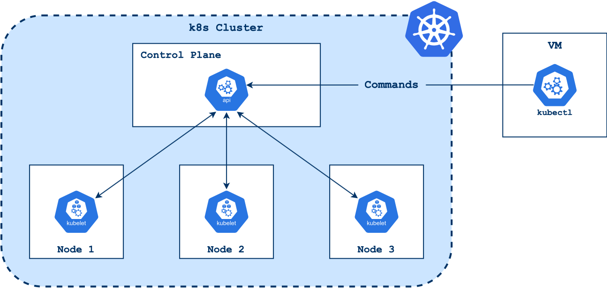

The **Control Plane** is responsible for communicating with and controlling Nodes and other Kubernetes objects in the cluster.

The Control Plane consists of several processes designed to manage different parts of the cluster, but, for the purposes of this course, the most important process to understand is the **API server**.

The API server communicates with each Node in the cluster via its kubelet agent (and vice versa).

To control the state of the cluster, one has to call the API server. This is typically done using the CLI tool kubectl.

### Kubernetes and the cloud

As previously mentioned, there are a number of cloud service providers, such as AWS, Azure and GCP, that offer their own Kubernetes service to users. This allows for the running and management of distributed systems, which in turn supports scaling, failover, rollback, and load balancing.

* Scaling and Load: Kubernetes offers both veritcal (increase power of pods) and horizontal scaling (increase number of pods) in the cloud. These services are often come as auto-scaling; depending on network traffic and stress, Kubernetes can automatically deploy more pods into a cluster in order to manage requests. Similarly, if the number of pods is above a minimum number set, the auto-scaler can scale back down.
* Failover: Whilst not an automated piece of functionality, Kubernetes and cloud-based solutions can allow for failover management within its clusters, passing over a workload to other clusters or pods (depending on the unit that has failed).
* Rollback: State management within the cloud and Kubernetes can allow for idempotency, changing the actual state of deployed Kubernetes pods to a configured and defined desired state.

**Kubectl**

**Overview**

To control and give instructions to a Kubernetes cluster, we need to interact with the cluster's API server.

The Kubernetes API can be easily interacted with using the kubectl CLI tool.

This module shows you how to install kubectl and introduces some basic commands.

**kubectl**



kubectl is a command-line tool that is used to send instructions to a Kubernetes cluster's API.

**Installation**

**Note:** If you have followed the instructions provided by the module *Azure Kubernetes Service*, kubectl will already be installed on your machine and you do **not** have to install it manually as shown here.

The latest stable binary release can be easily downloaded and installed with the following commands:

*# download*

curl -LO https://storage.googleapis.com/kubernetes-release/release/`curl -s https://storage.googleapis.com/kubernetes-release/release/stable.txt`/bin/linux/amd64/kubectl

*# make executable*

chmod +x kubectl

*# install the binary onto your PATH*

sudo mv ./kubectl /usr/local/bin/kubectl

**Configuration**

kubectl understands which cluster to connect to and how to authenticate using a configuration called a kubeconfig. By default, this is a file stored at ~/.kube/config.

This is an example of a of a kubeconfig that has automatically be configured with gcloud commands when using a managed cluster in Google Cloud Platform:

apiVersion: v1

clusters:

- cluster:

certificate-authority-data: LS0tLS1CRUdJTiBDRVJUSUZJQ0FURS0tLS0tCk1JSURERENDQWZTZ0F3SUJBZ0lSQUtzWGNEM1gzeEVTSkU3RDI1bVFycGd3RFFZSktvWklodmNOQVFFTEJRQXcKTHpFdE1Dc0dBMVVFQXhNa0 ... *# truncated*

server: https://35.246.88.63

name: gke_default-1551827562_europe-west2-c_test

contexts:

- context:

cluster: gke_default-1551827562_europe-west2-c_test

user: gke_default-1551827562_europe-west2-c_test

name: gke_default-1551827562_europe-west2-c_test

current-context: gke_default-1551827562_europe-west2-c_test

kind: Config

preferences: {}

users:

- name: gke_default-1551827562_europe-west2-c_test

user:

auth-provider:

config:

cmd-args: config config-helper --format=json

cmd-path: /usr/lib/google-cloud-sdk/bin/gcloud

expiry-key: '{.credential.token_expiry}'

token-key: '{.credential.access_token}'

name: gcp

We can easily configure the ~/.kube/config file when using a managed solution from any cloud provider.

Your current configuration can be viewed using this command:

kubectl config view

**Commands**

Basic commands for kubectl will allow you to make simple deployments and start to learn about different concepts in Kubernetes.

**run**

The run command can be used to run a specified image as a Pod in the cluster.

kubectl run <NAME> --image=<CONTAINER_IMAGE>

For example, to run an NGINX Pod:

kubectl run nginx --image=nginx:alpine

**create**

The create command will create a new Kubernetes object in the current cluster.

kubectl create <object> <arguments>

For example, to create an NGINX deployment:

# kubectl **create** deployment <**NAME**> *--image=<IMAGE>*

kubectl **create** deployment nginx *--image=nginx:alpine*

**get**

The get command can be used to list (or *get*) running objects, such as Pods, Services and Deployments.

For Pods:

*# get all pods*

kubectl get pods

*# get the pod called nginx*

kubectl get pod nginx

For Deployments:

*# get all deployments*

kubectl get deployments

*# get the deployment called nginx*

kubectl get deployment nginx

For Services:

*# get all services*

kubectl get services

*# get the service called nginx*

kubectl get service nginx

**describe**

To see detailed information about a resource, we can use describe.

kubectl **describe** <**RESOURCE**> <**NAME**>

For example, if we had an NGINX pod running we could see more information about its current state using:

kubectl describe pod nginx

Example Output

The Events: section, in particular, is very useful for troubleshooting problems, as it provides a running log of the state of the resource.

**expose**

At the point of creation, Pods are not connected to any network. They need to be connected to a Service in order exposed to the network.

To expose a running NGINX pod on port 80, we can use the following command:

# kubectl expose <RESOURCE> <RESOURCE_NAME> --port <PORT>

kubectl expose pod nginx --port 80

The default Service type is ClusterIP, which will expose the resource to other resources *within* the cluster.

To expose a Pod to an external network (such as the internet), we can use the NodePort type:

# kubectl expose <RESOURCE> <RESOURCE_NAME> --port <PORT> --type <SERVICE_TYPE>

kubectl expose pod nginx --port 80 --type NodePort

This will make the Pod accessible via all Nodes from a randomly-assigned high port such as 31904 (use kubectl get services to retrieve this port).

Alternatively, we could use a LoadBalancer service to assign a specific port:

# kubectl expose <RESOURCE> <RESOURCE_NAME> --port <PORT> --type <SERVICE_TYPE>

kubectl expose pod nginx --port 80 --type LoadBalancer

The --port flag will define both the port users connect to *and* the target port that the LoadBalancer Service redirects traffic to.

If the port you want users to connect to is different to the port that the app is running on in the container, you can define the --target-port separately:

# kubectl expose <RESOURCE> <RESOURCE_NAME> --port <ACCESSIBLE_PORT> --type <SERVICE_TYPE> --target-port <CONTAINER_PORT>

kubectl expose pod nginx --port 90 --type LoadBalancer --target-port 80

**set**

The set command can be used to update various properties for a resource.

Here is an example of the set command being used to update the image to nginx:latest for a running Pod called nginx which has a container called nginx:

# kubectl **set** image <RESOURCE>/<NAME> <CONTAINER>=<IMAGE>

kubectl **set** image pod/nginx nginx=nginx:latest

When performed on a *Deployment* (deployment/nginx for example) a rolling update will be performed.

This is great when deploying new versions of your application. Make sure you use a different tag for the image when doing this to ensure that the new version is deployed.

**edit**

The edit command can be used to edit resources on the cluster.

By default, the vim text editor is used.

Simply reference the resource that you would like to edit:

# kubectl **edit** <RESOURCE>/<NAME>

kubectl **edit** pod/nginx

You will then be able to make edits to the configuration, they will be applied when you save and exit.

**delete**

We can use the delete command to specify a resource to delete:

# kubectl **delete** <RESOURCE> <NAME>

kubectl **delete** pod nginx

**Manifests**

**Manifests** are configurations that are used to define the *desired state* of an object in a Kubernetes cluster. They are written in either YAML or JSON format.

**Note:** Each object has a single manifest, but a configuration file can contain multiple manifests. For YAML files, each manifest must be separated by a --- line.

Having all of the objects configured in these files makes it much easier to create multiple objects, and means that they can be maintained using version control.

Here's an example of a manifest defining a single NGINX Pod:

apiVersion: v1

kind: Pod

metadata:

name: nginx

labels:

app: nginx

spec:

containers:

- name: nginx

image: nginx:alpine

ports:

- containerPort: 80

Kubernetes is an open-source container orchestration tool, meaning that anyone can develop their own components. This means that manifest configurations differ in structure per object.

**Remember:** The best place to go to find a manifest template for a Kubernetes object is the [official documentation](https://kubernetes.io/docs/home/).

However, they typically contain these four mappings:

| **Section** | **Explanation** |
| --- | --- |
| apiVersion: | The version of the API, e.g. v1. This will differ between objects and it is best to refer to the documentation if you are unsure which to use. |
| kind: | The type of object we are defining, such as pod, deployment or service. |
| metadata: | Provides information about the object, such as the name of the object and the labels attached to it. |
| spec: | The specification for the object itself. For a Pod, this would include information about its containers, volumes, hostname, scheduling and more. |

Let's break down the manifest for our NGINX Pod:

apiVersion: v1

kind: Pod

We first define what type of object we're describing with the manifest. As we're describing a Pod, we set its kind: accordingly. The API definition for Pods is found under v1.

metadata:

name: nginx

labels:

app: nginx

We then use the metadata: mapping to give the object a name and provide it with labels. Labels are key-value pairs that we use to tag groups of resources.

spec:

containers:

- name: nginx

image: nginx:alpine

ports:

- containerPort: 80

Finally, we define the state of the Pod itself using the spec: mapping. This is a simple Pod and only contains the definition for an NGINX container.

The container is given a name (nginx), the Docker image is defined nginx:alpine and exposes the port (80).

**Note:** The port definition is mainly informational rather than functional, just as exposing a port in a Dockerfile is – you do not *need* to expose a port in the spec to enable network connectivity to the container.

Note that the containers: mapping expects a list of items. This is because Pods can have one *or more* containers associated with it.

**apply a Manifest**

You can create the objects defined in a manifest using kubectl with the -f argument:

# **kubectl** **create** **-f** [TEMPLATE_FILE]

**kubectl** **create** **-f** **nginx**.yaml

create commands will only work if the defined configuration does not already exist.

If you want to update an existing configuration with a new one, you can use apply instead:

# kubectl apply -f [TEMPLATE_FILE]

kubectl apply -f nginx.yaml

apply commands will also work if the configuration has not been created yet, and so it tends to be the more useful command to use.

You may use these commands on directories if you would like to apply multiple templates:

# kubectl apply -f [DIRECTORY]

kubectl apply -f ./configs

To *recursively* apply manifests within subdirectories, the -R option can be included:

# kubectl apply -R -f [DIRECTORY]

kubectl apply -R -f ./configs

**Tutorial**

This tutorial takes you through creating an NGINX Pod and LoadBalancer Service using manifests and some of the commands shown in this module.

**Prerequisites**

You will need a cluster set up for this tutorial.

It's recommended that you have provisioned a managed cluster using GKE, EKS or AKS.

**Install kubectl**

Note: If you have followed the *Azure Kubernetes Service* module's tutorial for setting up a cluster, you will already have kubectl installed and can skip to [this step](https://qa-community.co.uk/~/_/learning/lbg-container-orchestration/kubernetes--kubectl#create-the-deployment-and-service). Run kubectl --help to check.

Use these commands to install kubectl:

*# download kubectl*

curl -LO https://storage.googleapis.com/kubernetes-release/release/`curl -s https://storage.googleapis.com/kubernetes-release/release/stable.txt`/bin/linux/amd64/kubectl

*# make executable*

chmod +x kubectl

*# install binary in to your PATH*

sudo mv ./kubectl /usr/local/bin/kubectl

**Configure Access to Your Cluster**

Update the ~/.kube/config file with the details of your current cluster.

Cloud-provider managed solutions will have a command to do this for you.

You need to do this to be able to authenticate, and therefore communicate, with your cluster.

**Check Your Configuration**

You should now be able to see that your kubeconfig has been set up for access to your cluster:

kubectl config view

**Create the Deployment and Service**

Create configuration file called nginx.yaml with the following contents:

apiVersion: v1

kind: Service

metadata:

name: nginx

spec:

selector:

app: nginx

ports:

- protocol: TCP

port: 80

targetPort: 80

type: LoadBalancer

**---**

apiVersion: v1

kind: Pod

metadata:

name: nginx

labels:

app: nginx

spec:

containers:

- name: nginx

image: nginx:alpine

ports:

- containerPort: 80

You should then be able to create this with the following command:

**kubectl** **create** **-f** **nginx**.yaml

You should see the following output:

**service**/**nginx** created

pod/nginx created

**Check the Application is Accessible**

List all the Pods running in the cluster:

kubectl get pods

Output:

NAME READY STATUS RESTARTS AGE

nginx 1/1 Running 0 26s

describe the Pod to view more information about it:

kubectl describe pod nginx

If you run into any issues with a resource, try describing it to troubleshoot the problem.

List all the Services running in the cluster:

kubectl get services

Output:

NAME TYPE CLUSTER-IP EXTERNAL-IP PORT(S) AGE

kubernetes ClusterIP 10.96.0.1 <none> 443/TCP 107s

nginx LoadBalancer 10.107.31.96 <pending> 80:32635/TCP 47s

Assuming you are using a cloud-based managed Kubernetes service, the LoadBalancer named nginx will take a while to provision an external IP address to connect to. This is because the cloud provider is provisioning a separate load balancer resource for you.

Run the get command again until the EXTERNAL-IP column shows an IP address. Copy it into your browser and you should see the default NGINX home page:

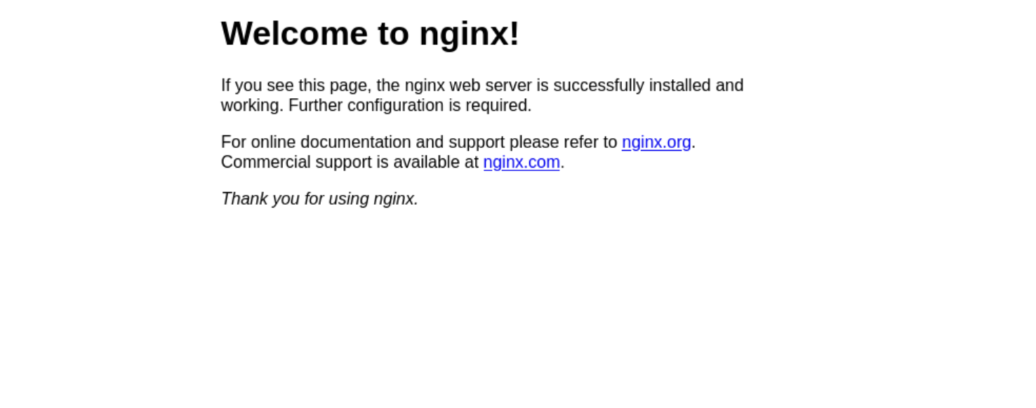

**Change the NGINX Container to Apache**

Let's update the Deployment object now so that it is running an Apache (httpd) container instead:

kubectl set image pod/nginx nginx=httpd:alpine

You should now be able to keep trying the public IP address again and it will change from NGINX being served to an Apache server. If successful, refreshing the page will show the message: 'It works!' (you may have to perform a hard refresh).

Now, change it back to the original configuration using the apply command:

kubectl apply -f nginx.yaml

**Delete the Resources**

As our configuration was defined using manifests, we can simply reference the nginx.yaml configuration file to delete them:

kubectl **delete** -f nginx.yaml

**Exercises**

1. Create a pod which runs your own Docker container and expose it as a Load Balancer service.
2. Create a script that will:
   * Build a new Docker image as a new version.
   * Push the image to a registry, Docker Hub for example.
   * Update the image running in the Pod in the cluster.

Notes

We invoke the API client for cluster API using kubectl <verb><resource><args/flags>

gcloud container clusters list – shows containers

manifests are yaml files to define the state we want a resource to have

**Pods**

-basic unit of work

-wrapper around one or more containers

-prevents open container ports from being accessed by default

-all containers in pod share same address space – one IP per pod

Give abstraction level over having raw containers

**Services**

* **Allows us to communicate to pods from outside world (by associating a service to a pod)**
* **3 service types:**
  + **clusterIP –** enable pop-pod communication
  + **nodePort –** external communication via node port mapped to clusterIP
  + **LoadBalancer – c**create nodePort, set up external LB to direct traffic to relevant port on nodes

**Services** are required to expose your Pods to a network, be that within the cluster or to an external network, such as the internet.

Any Pod that needs network connectivity must be associated with a Service.

This module explains the key components of a Kubernetes Service.

## Services



To expose a Pod to a network, it needs to be associated with a Service object.

Different types of Services define different networking rules and capabilities. For example, a ClusterIP-type Service will only expose a Pod to other Pods within the cluster, whereas a LoadBalancer-type Service will expose a Pod to an external network.

Pods within a cluster are assigned internal IP addresses. Services allow the use of hostname resolution to resolve names to IP addresses, allowing applications to refer to the name of the Service as a network location in order to communicate with each other.

### Template

For a full list of configurations accepted by the Kubernetes API for Services, please consult the [documentation](https://kubernetes.io/docs/reference/kubernetes-api/Service-resources/Service-v1/).

Here is an example of a Service manifest for an NGINX Pod:

apiVersion: v1

kind: Service

metadata:

name: nginx

spec:

selector:

app: nginx

ports:

- protocol: TCP

port: 80

Let's break this manifest down further.

apiVersion: v1

kind: Service

This section defines that we are creating a Service object according to the apiVersion: v1 specification.

metadata:

name: nginx

Defining the name: mapping under the metadata: section gives the Service a name. Pods within the cluster will then be able to refer to this network location using this name.

spec:

selector:

app: nginx

ports:

- protocol: TCP

port: 80

The spec: section provides the Service's configuration.

The selector: mapping is used to associate the Service with another object, such as a Pod. In the above example, the Service will direct any network traffic sent to the Service to any Pod with the label app: nginx.

The ports: mapping specifies which ports the Service will expose. The above example will direct any traffic to the Service on port 80 to the Pod on port 80.

If you wanted the exposed port and the target port (the Pod's port) to be different, you could also specify the targetPort:

ports:

- protocol: TCP

port: 80

targetPort: 8080

## Types

There are 3 types of Service explored in this module: **Cluster IPs**, **Node Ports** and **Load Balancers**.

All three play different roles and are used in different scenarios.

### ClusterIP

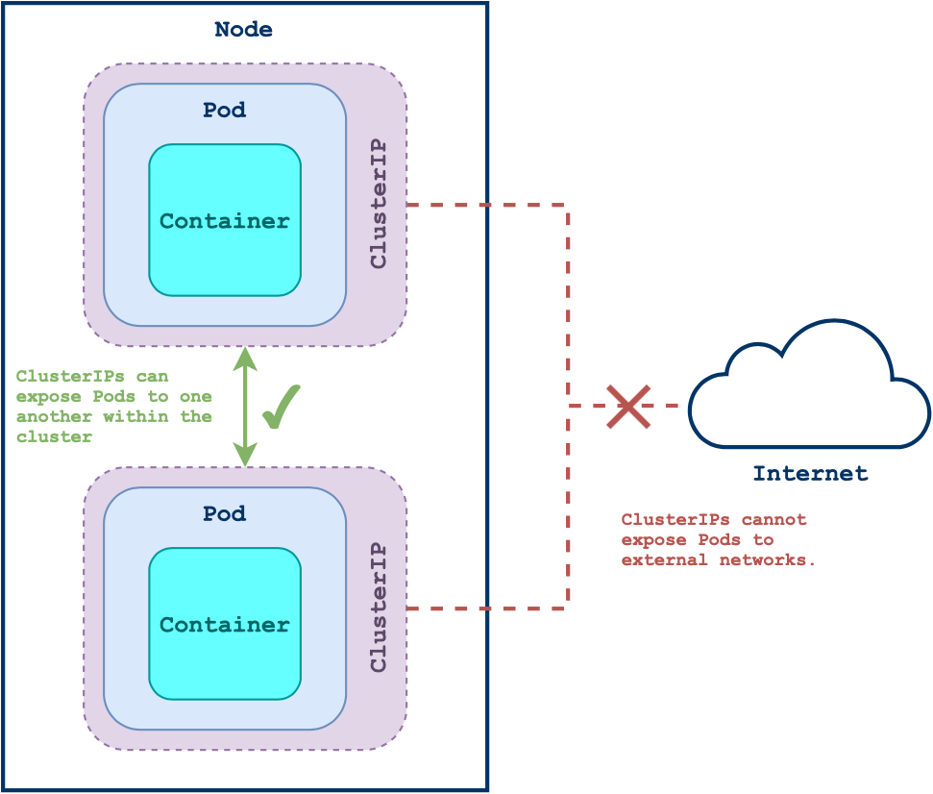

ClusterIP Services expose the resource within the cluster by assigned it an internal IP address.

This means the Service can only be reached from within a cluster and cannot be reached from outside. This is a default Service type.

#### Template

Here is an example of a ClusterIP service associated with an SQL database Pod:

apiVersion: v1

kind: Service

metadata:

name: webapp-database-sql

spec:

type: ClusterIP

selector:

app: webapp-database-sql

ports:

- protocol: TCP

port: 3306

By associating the database with a ClusterIP Service, it is exposed to any Pods within the cluster (such as a backend application) but cannot be accessed from outside of the cluster.

This provides a layer of security to our database Pod by limiting what can connect to it.

### Node Port

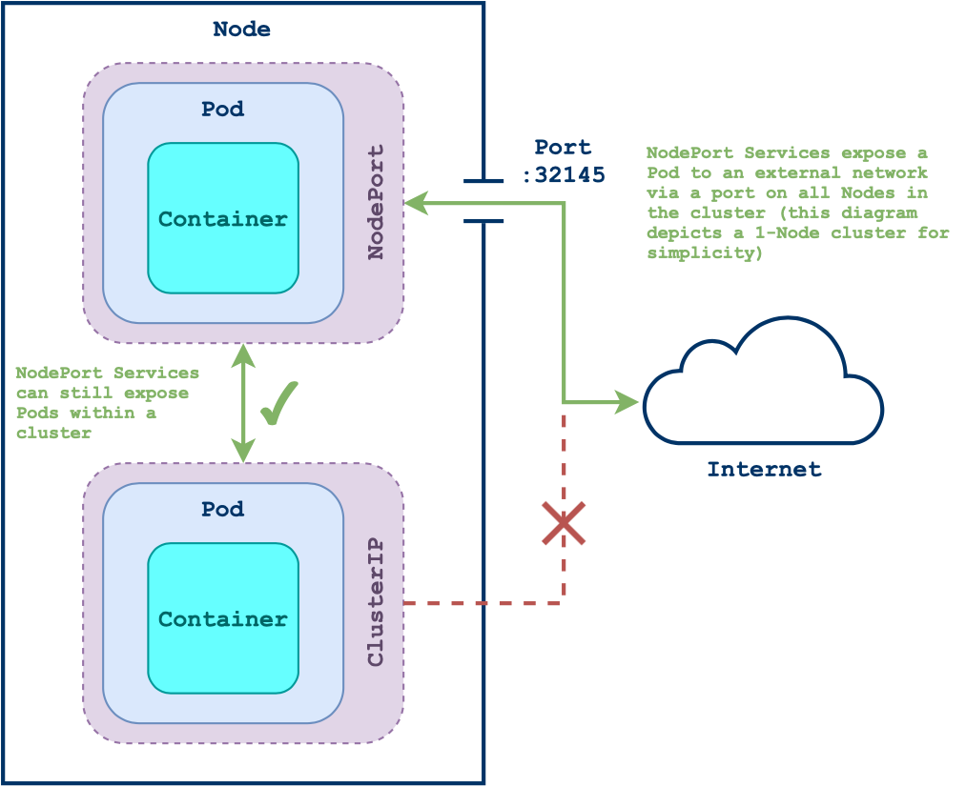

Setting the Service type to NodePort exposes your Service to an external network via each Node’s IP at a static port.

A NodePort opens a port on every node of your cluster. When traffic is sent to this port it is automatically forwarded to the Service.

If a specific port is not defined, Kubernetes will assign the service a random high-number port.

#### Template

Here is an example of NodePort Service manifest:

kind: Service

apiVersion: v1

metadata:

name: nginx

spec:

type: NodePort

selector:

app: nginx

ports:

- protocol: TCP

port: 8080 # Defines the Service's port within the cluster

targetPort: 80 # Defines the Pod's port

nodePort: 32000 # Defines the port the Service can be accessed **from** on the node's IP

This nginx Service will be exposed internally to other cluster applications on port 8080 and externally from the cluster on the NodeIP address on port 32000. It will also send requests being made to any Pods with the label app: nginx on port 80.

### LoadBalancer

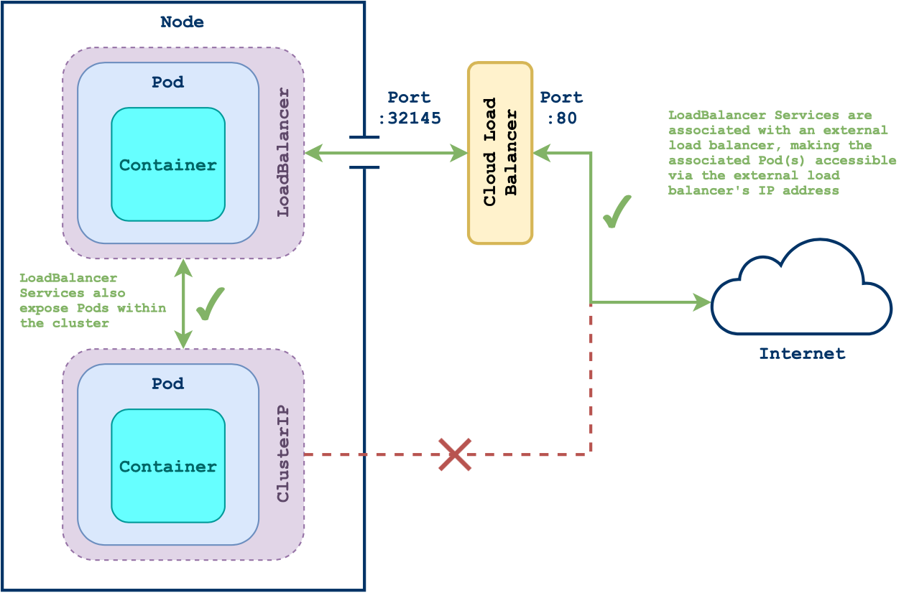

Services that are assigned the type LoadBalancer are exposed externally and are assigned an external IP address.

When creating a LoadBalancer Service in a cloud-provider managed Kubernetes service (such as EKS, AKS or GKE), a separate load balancer cloud resource will be created.

The LoadBalancer Service will be associated with this load balancer resource and its external IP address. The Pod(s) associated with the LoadBalancer resource will then be accessible via that external IP address.

Running kubectl get services will show the Service's external IP address once it has been assigned. If it shows the external IP as <pending>, the load balancer resource is still being provisioned.

#### Template

kind: Service

apiVersion: v1

metadata:

name: nginx

spec:

type: LoadBalancer

selector:

app: nginx

ports:

- protocol: TCP

port: 80 *# Defines the Service's port within the cluster*

targetPort: 80 *# Defines the Pod's port*

When this Service is created it will be assigned an external IP once the external load balancer resource has been provisioned by the cloud provider.

## Tutorial

This tutorial shows you how to create two Pods with Services attached:

* a simple frontend Python application that shows a page with a red background that will be exposed to the internet with a LoadBalancer Service.
* a simple backend Python application that generates a random string of letters that will be exposed within the cluster with a ClusterIP Service.

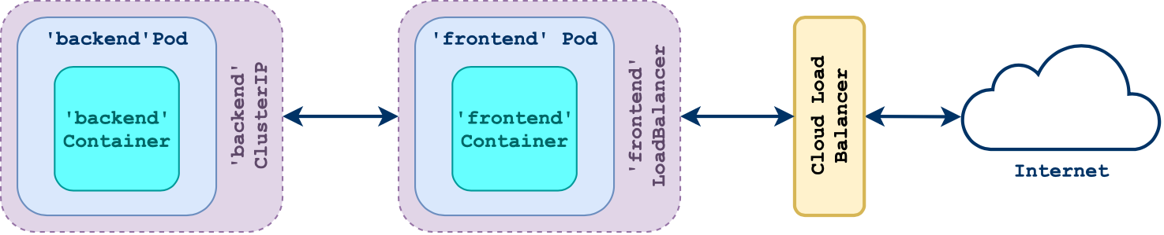

The frontend application makes a request to the backend to retrieve the random string of letters upon a refresh, so it can display the string in the browser.

**Note:** The apps we're using here have been prebuilt and are accessible on Docker Hub, so there is no need to work with the source code itself. But if you are interested, the code this tutorial is based on can be found here: <https://gitlab.com/qacdevops/python-front-and-back>

### Prerequisites

This module assumes you have created a Kubernetes cluster, have kubectl installed and have configured it to connect to your cluster.

### Create the File Structure

Create a folder for this tutorial and create a YAML file for our app's manifest:

**mkdir** k8s-**tutorial**-services && **cd** $_

touch frontend.yaml backend.yaml

### Create the Frontend

Open the frontend.yaml file with the text editor of your choice and copy in the following code:

apiVersion: v1

kind: Service

metadata:

name: frontend

spec:

type: LoadBalancer *# set the type of Service*

selector:

app: frontend *# referencing the Pod's label*

ports:

- protocol: TCP

port: 5000

targetPort: 5000

**---**

apiVersion: v1

kind: Pod

metadata:

name: frontend

labels:

app: frontend *# needs to be the same as Service's selector*

spec:

containers:

- name: frontend

image: htrvolker/python-frontend:red

ports:

- containerPort: 5000

Above we are defining two manifests: one for the LoadBalancer Service, and one for our frontend Python server, which is running as a single Pod.

This will expose the frontend to the internet via a load balancer, allowing you to connect to it on your browser.

The selector: mapping under spec: in the Service manifest is referencing the app: frontend label found under the Pod's metadata: mapping. This is how the Service becomes associated with the Pod.

We can then apply these manifests with:

kubectl apply -f frontend.yaml

### Create the Backend

Open the backend.yaml file with the text editor of your choice and copy in the following code:

apiVersion: v1

kind: Service

metadata:

name: backend

spec:

type: ClusterIP *# set the type of Service*

selector:

app: backend *# referencing the Pod's label*

ports:

- protocol: TCP

port: 5001

targetPort: 5001

**---**

apiVersion: v1

kind: Pod

metadata:

name: backend

labels:

app: backend *# needs to be the same as Service's selector*

spec:

containers:

- name: backend

image: htrvolker/python-backend:letters

ports:

- containerPort: 5001

Above we are defining two manifests: one for the ClusterIP Service, and one for our backend Python server, which is running as a single Pod.

This will expose the backend to the cluster's internal network, allowing the frontend Pod to send HTTP requests to it.

The frontend app is written to make requests to a network location called backend on port 5001, so it is important that the Service reflects this.

We can then apply these manifests with:

kubectl apply -f backend.yaml

### Access the Application

To find the external IP address of the LoadBalancer Service, run:

kubectl get services

You may see that the external IP address associated with the frontend Service is set to <pending>:

NAME TYPE CLUSTER-IP EXTERNAL-IP PORT(S) AGE

backend ClusterIP 10.100.177.121 <none> 5001/TCP 7s

frontend LoadBalancer 10.109.243.17 <pending> 5000:32297/TCP 7s

kubernetes ClusterIP 10.96.0.1 <none> 443/TCP 19h

If so, it means your cloud provider has not finished provisioning the external load balancer associated with the Service. Wait a bit and run the command again until you see the external IP address appear.

Once you have the IP address, copy it into your browser and access the application on port 5000. You should see a page that looks like this:

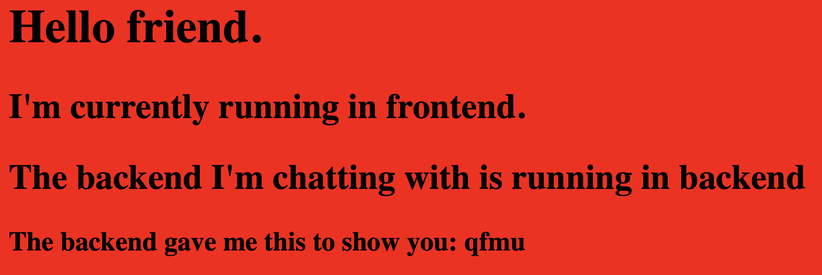

### Clean Up

To remove the Pods and Services, simply run this delete command while in your tutorial directory:

kubectl **delete** -f .

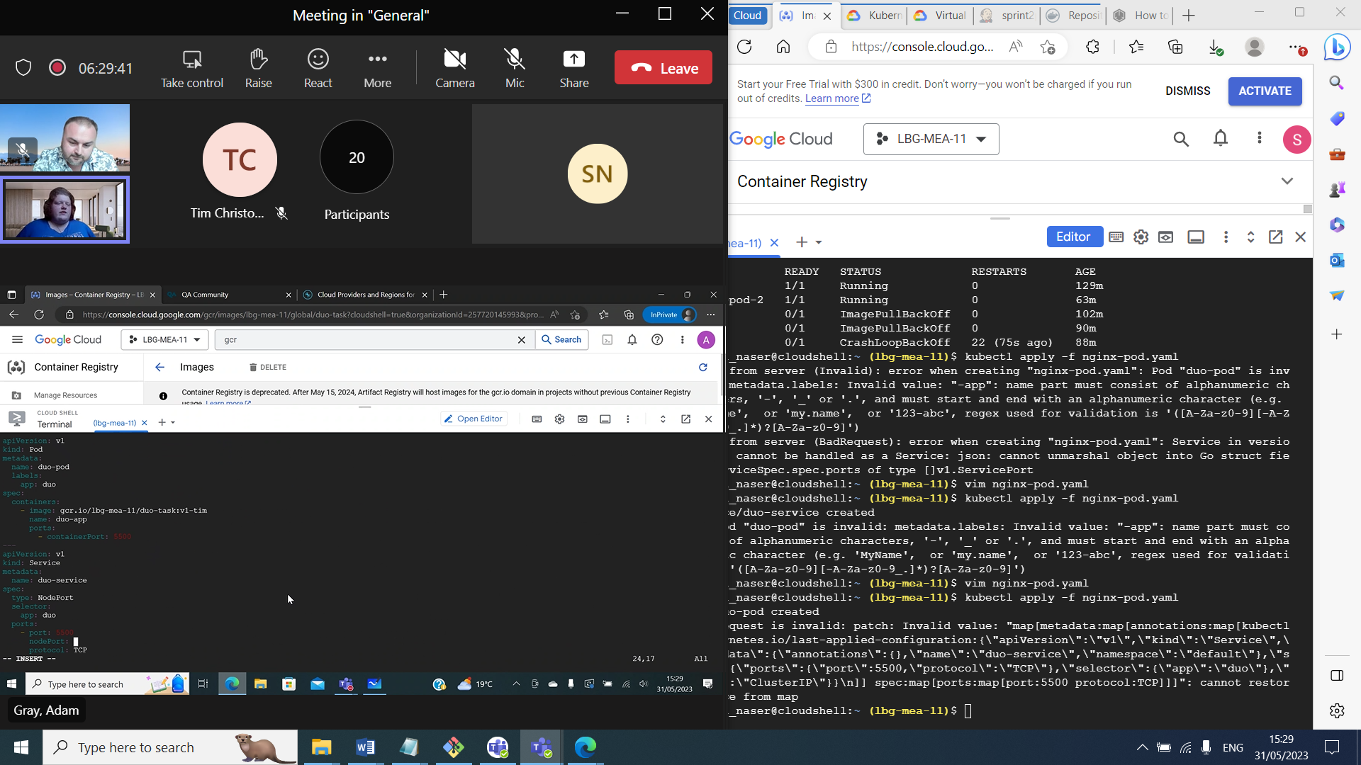

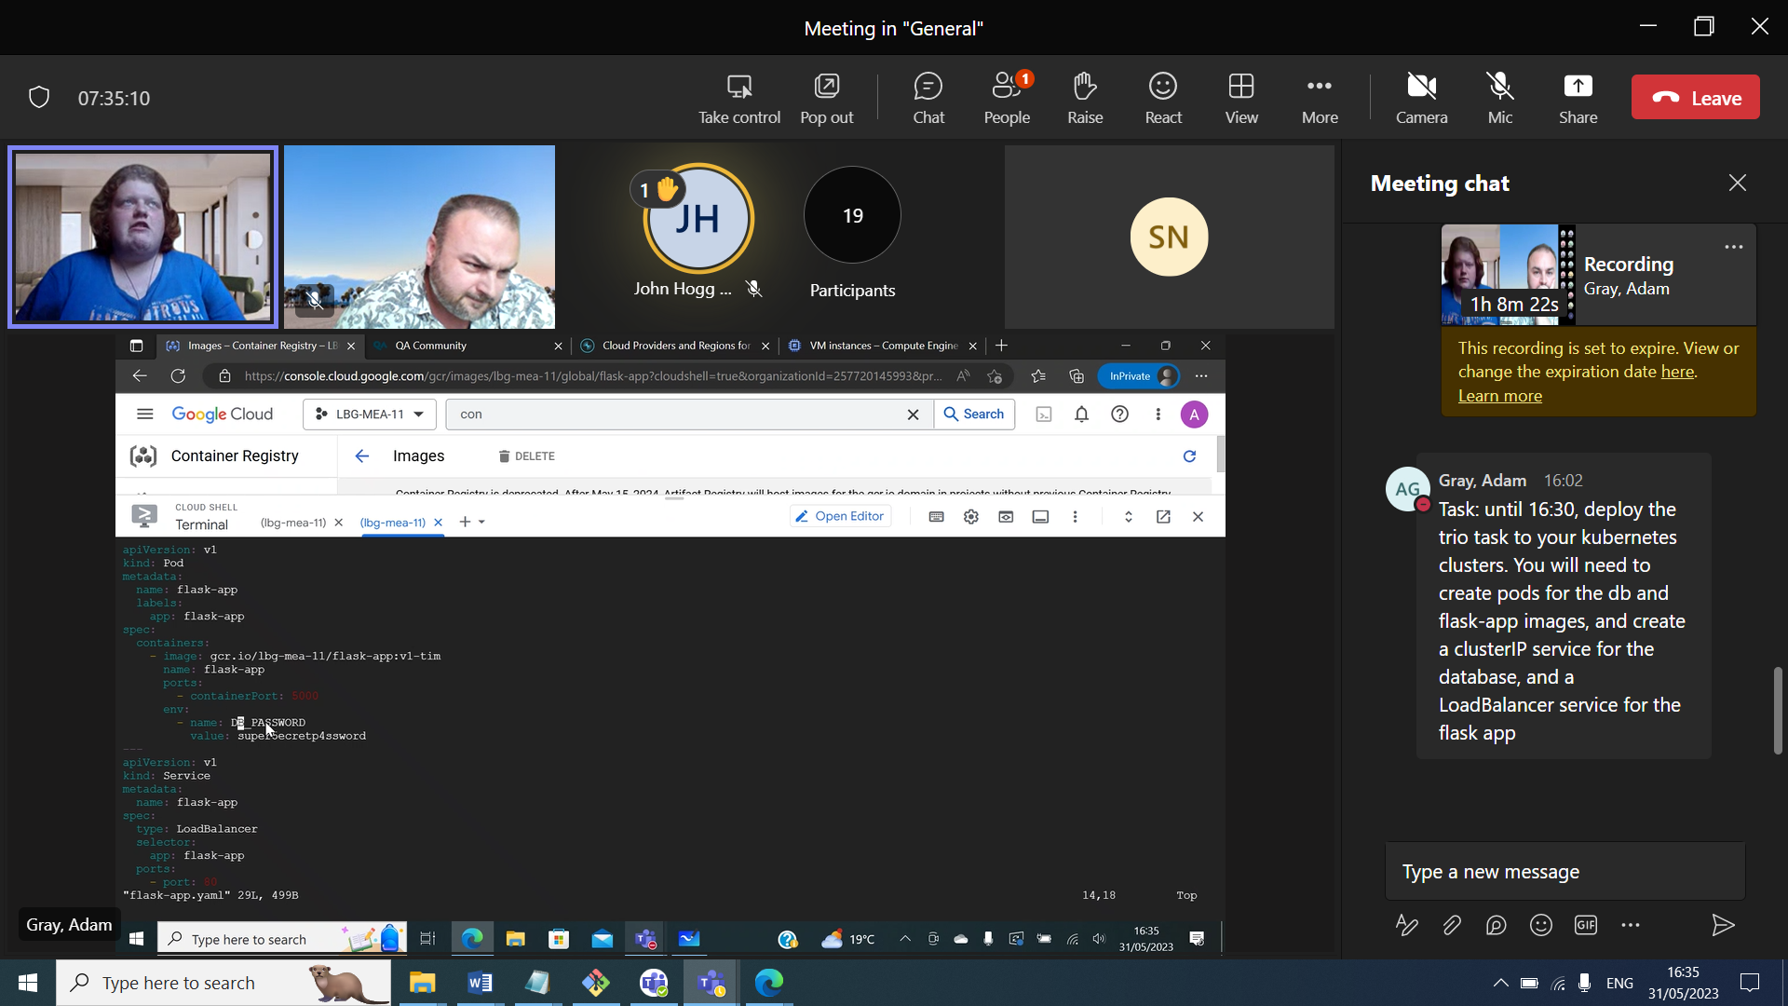

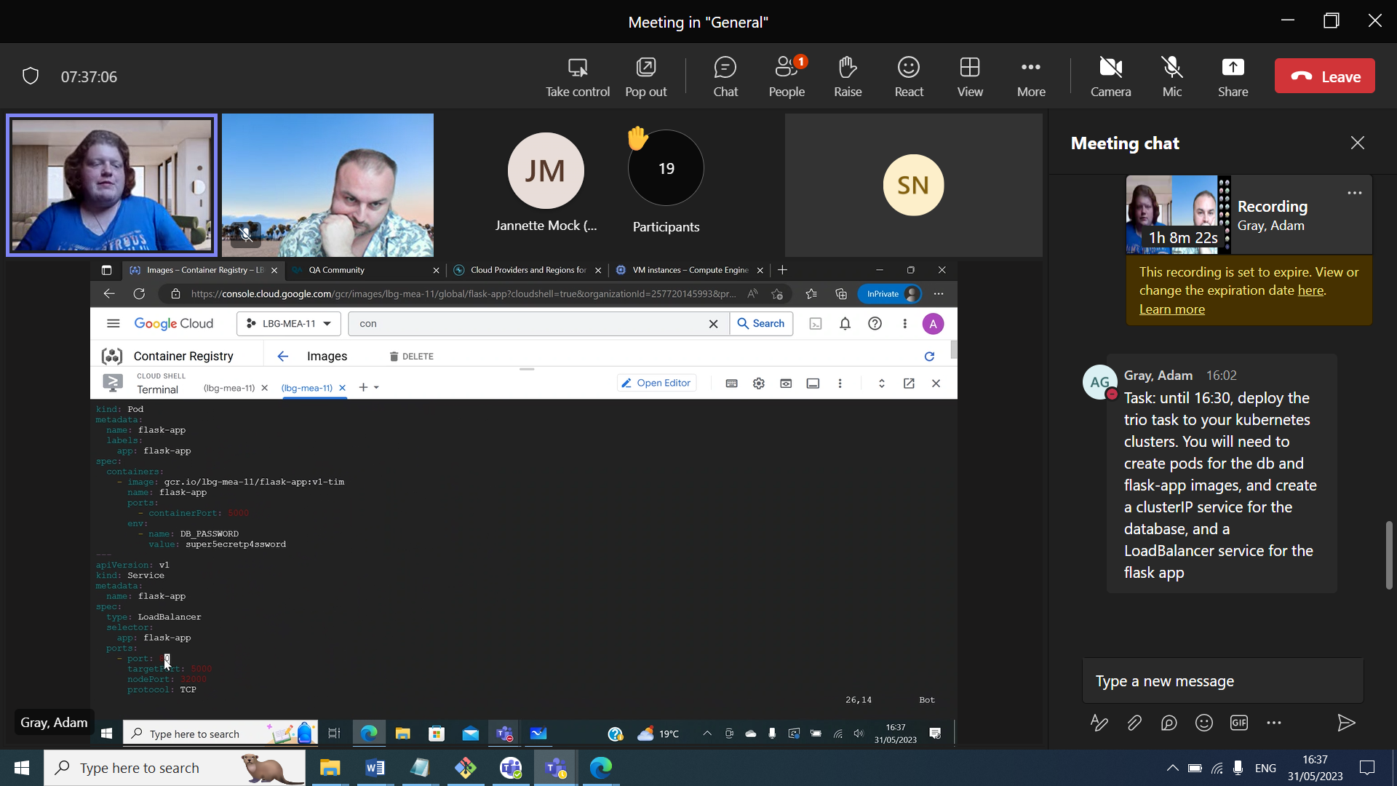

Mysql listens on poer 3306

Find name and port in URI in app.py

**Controllers**

ReplicaSets

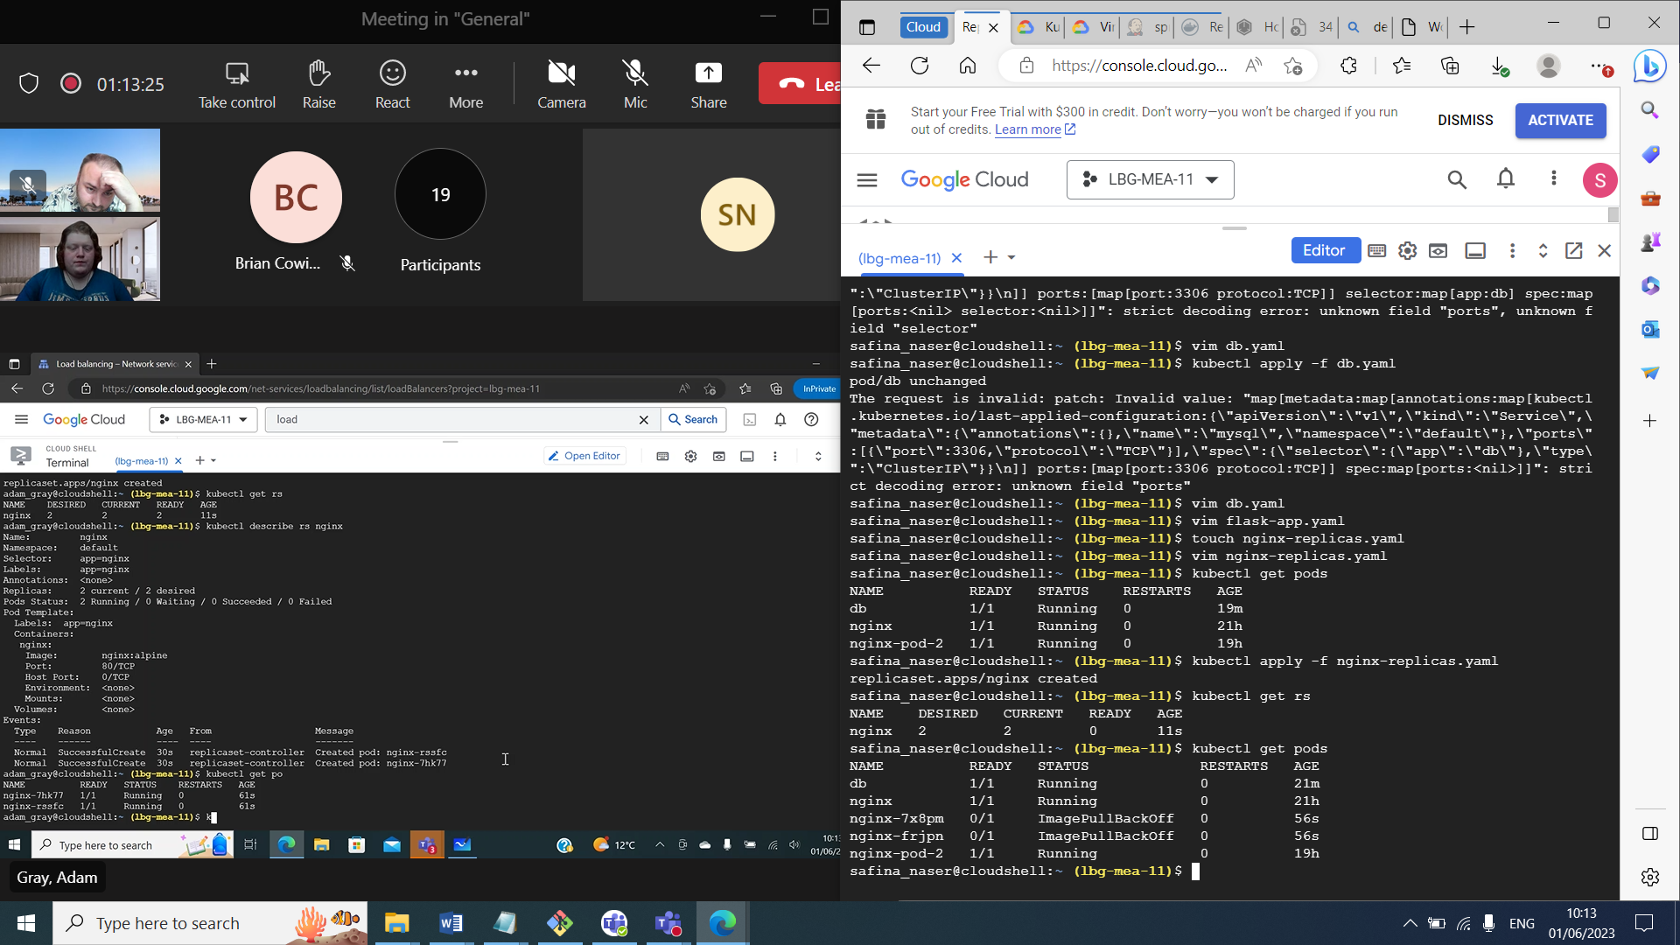

Deployments create replica sets in the background

* Create a deployment with a template which will create a replica set. If you perform an update it will create a new replica set

Config map

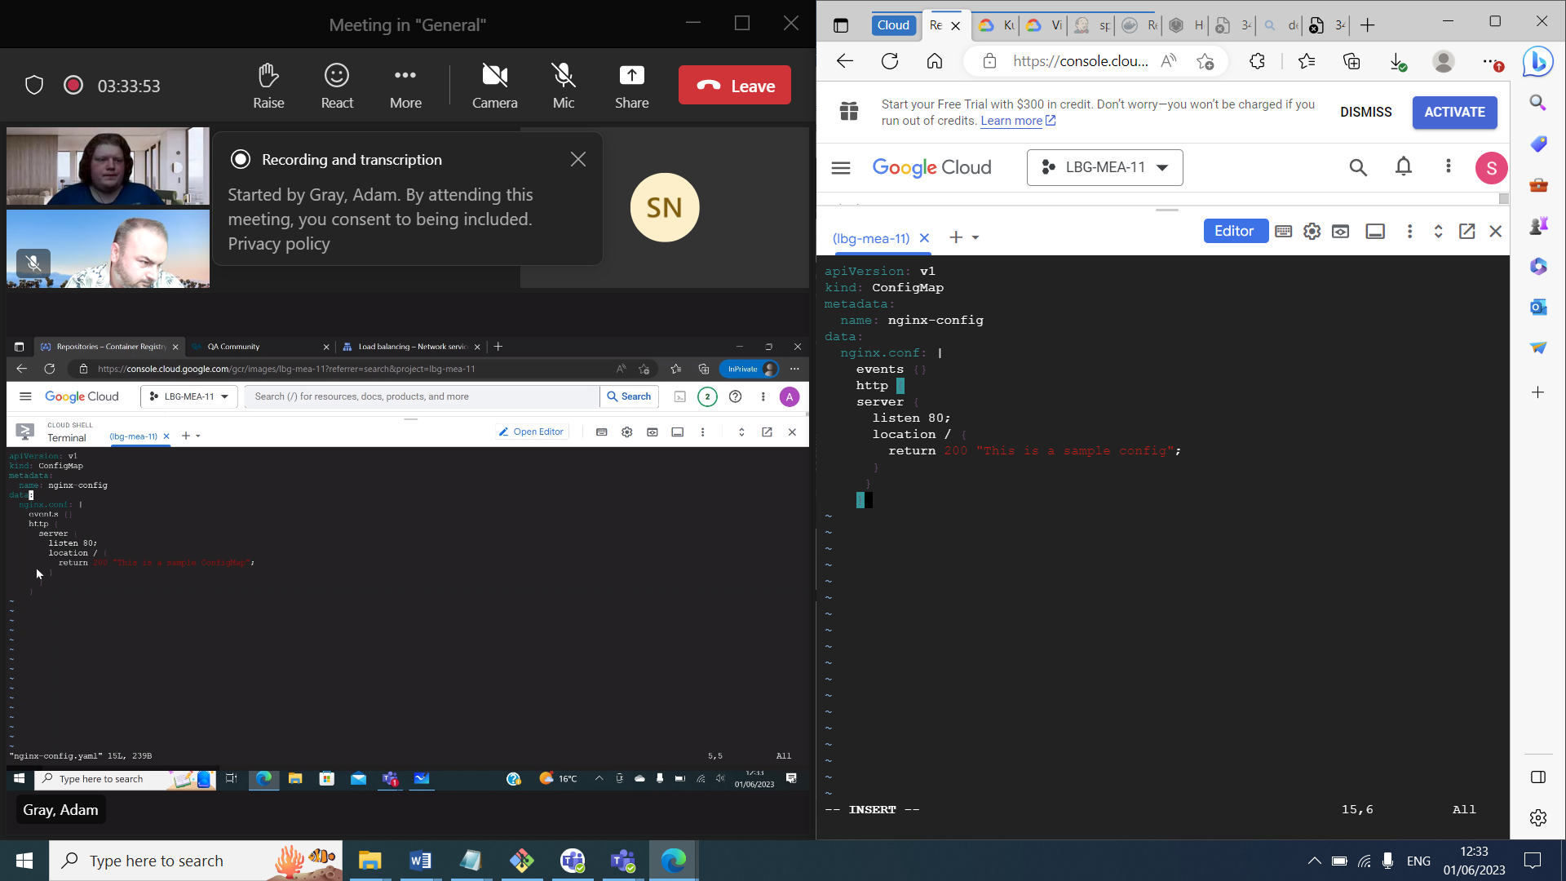

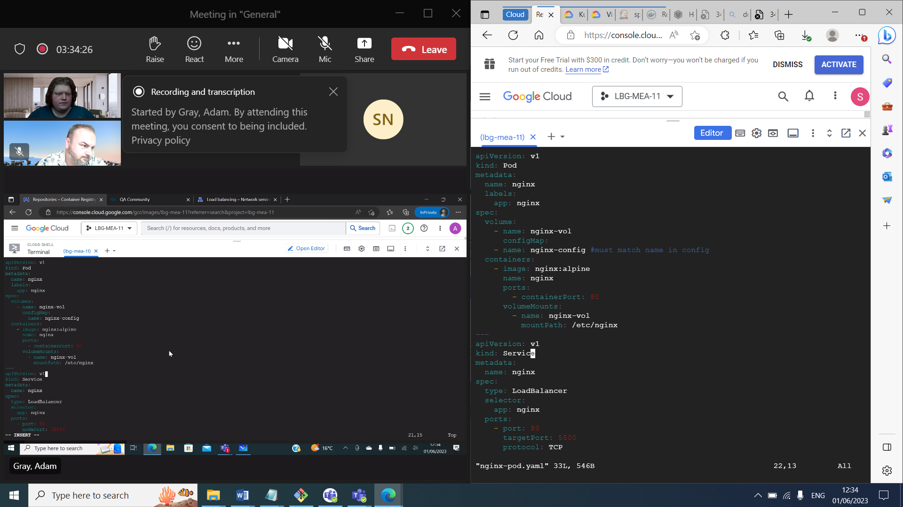

You can easily scale a ReplicaSet in and out with the command:

kubectl scale --replicas=<NUMBER_OF_REPLICAS> replicaset/<REPLICASET_NAME>

ReplicaSets are **not** suited for collections of Pods whose configurations are likely to change, such as for a rolling update. In this case, you should use a [Deployment](https://qa-community.co.uk/~/_/learning/lbg-container-orchestration/kubernetes--controllers#deployments).

**Note:** the [Kubernetes documentation](https://kubernetes.io/docs/concepts/workloads/controllers/replicaset/#when-to-use-a-replicaset) actually recommends using Deployments over ReplicaSets in most scenarios, as their configurations make use of ReplicaSets anyway while providing more functionality.

#### Template

For a full list of configurations accepted by the Kubernetes API for Deployments, please consult the [documentation](https://kubernetes.io/docs/reference/kubernetes-api/workload-resources/replica-set-v1/).

Here is an example of a ReplicaSet manifest for an NGINX application:

apiVersion: apps/v1

kind: ReplicaSet

metadata:

name: nginx

labels:

app: nginx

spec:

replicas: 3

selector:

matchLabels:

app: nginx *# must be the same value as the label in the template*

template:

metadata:

labels:

app: nginx *# this label is assigned to each pod in the set*

spec:

containers:

- name: nginx

image: nginx:alpine

The selector: mapping must reference the same label specified under the metadata: mapping under the template: section. This is how the ReplicaSet is associated with the Pods it is managing.

### Deployments

**Deployments** are very similar to ReplicaSets, and in fact are extensions of the ReplicaSet Controller. They manage and maintain replicas of Pods to provide availability and resiliency.

The added benefit of a Deployment is its ability to manage rolling updates.

#### Template

For a full list of configurations accepted by the Kubernetes API for Deployments, please consult the [documentation](https://kubernetes.io/docs/reference/kubernetes-api/workload-resources/deployment-v1/).

Here is an example of a Deployment manifest for an NGINX application:

apiVersion: apps/v1

kind: Deployment

metadata:

name: nginx

labels:

app: nginx

spec:

replicas: 10

selector:

matchLabels:

app: nginx

strategy:

rollingUpdate:

maxSurge: 10%

maxUnavailable: 25%

template:

metadata:

labels:

app: nginx

spec:

containers:

- name: nginx

image: nginx:alpine

ports:

- containerPort: 80

It is very similar to the ReplicaSet manifest. The only visible difference (other than kind: Deployment) is the addition of the strategy: mapping:

strategy:

rollingUpdate:

maxSurge: 10%

maxUnavailable: 25%

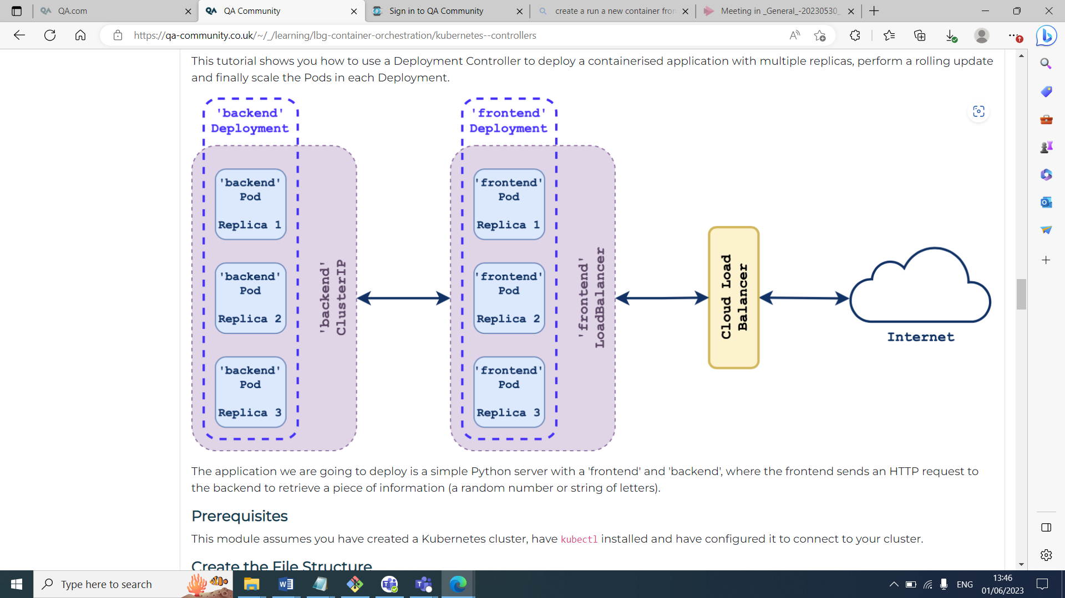

Namespaces:

NS in kubernetes cluster is like a project on GCP so isolated and independent of other ns etc

* You can assign resources to each ns
* A logical grouping of resources ie a subcluster of the k8 cluster
* Can separate environments

Eg dev team a dev/staging/prod dev team b….having own ns

* Kubectl get ns, kubectl api-resources
* 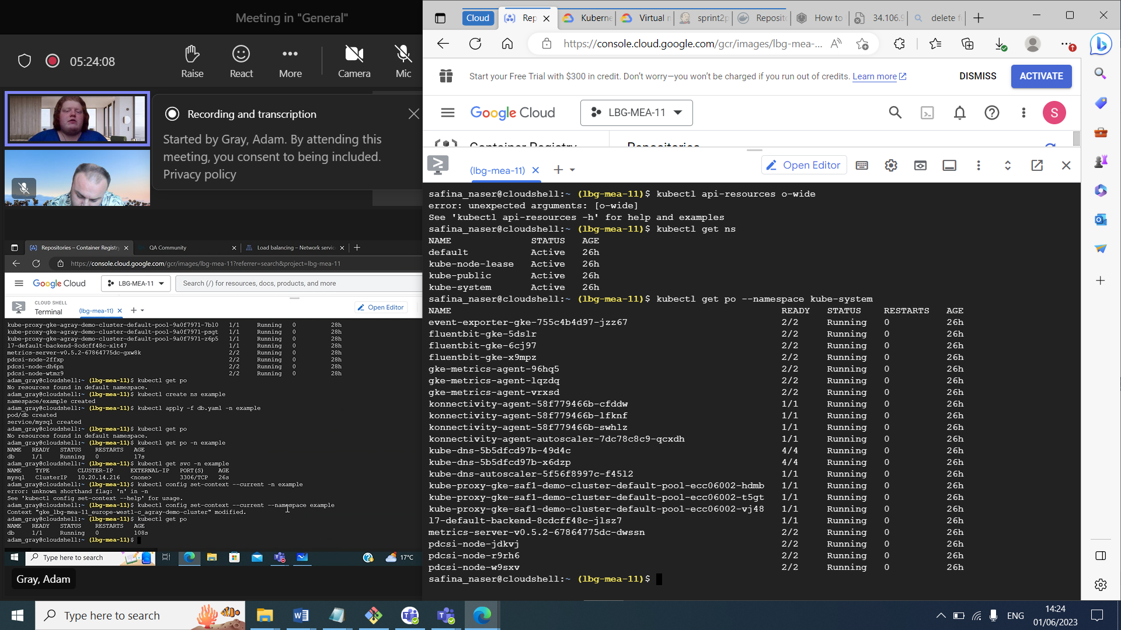

Secret

